**Word Document (Password Encryption) Step by Step**

1. **Go to File**

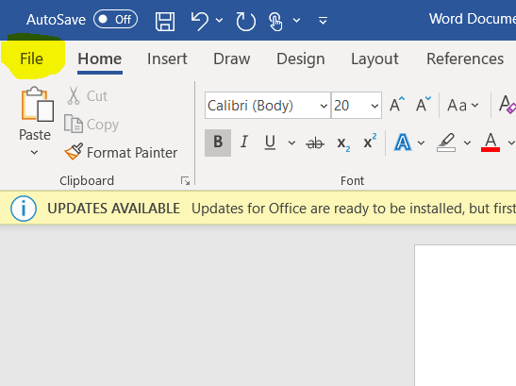

1. **Save**

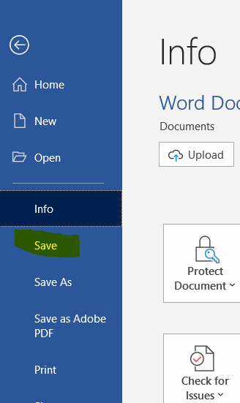

1. **Protect Document**

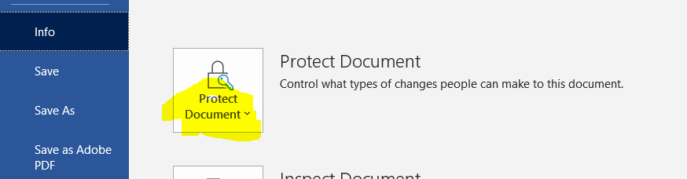

1. **Encrypt with password**

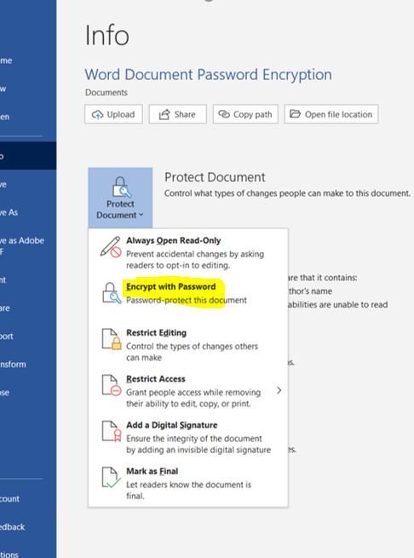

1. **Type in a password (don’t forget it!!!)**

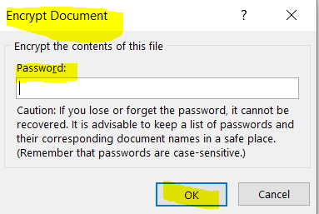

1. **Save again**

